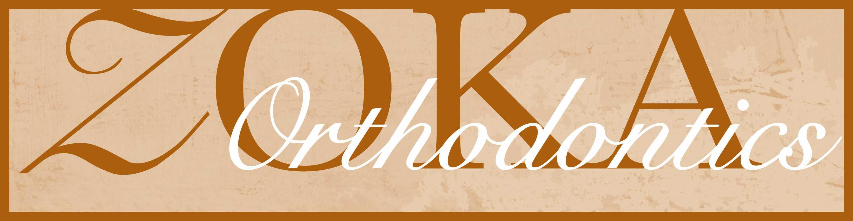

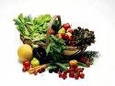

The glue and the cement that holds your brackets and bands on your teeth are only strong enough to allow the braces and the force of the wires to move your teeth, and cannot withstand the forces of biting the wrong food. Please use the following list as a more detailed example of foods to avoid. Keep in mind that excessive broken appliances can prolong treatment time. It is our goal to treat your case as quickly and efficiently as possible.

WATCH OUT FOR

- Anything crunchy. Including nuts, hard pizza crust, hard French bread, and hard shell tacos

- Anything chewy. This includes all candies and tough meat. Cut your meats into small pieces, cut rib meat off the rib, and cut fried chicken meat off the bone. DO NOT BITE IT OFF.

- Apples, pears, peaches, and raw vegetables of any type should be cut into small, bite-size pieces. Chew them on your back teeth. NEVER BITE DIRECTLY INTO THEM.

- Cookies of all types. Break them into tiny pieces and chew very carefully.

- Cereal. Small spoonfuls.

- No ice crunching, bone chewing, pen cap chewing or fingernail biting.

- Corn on the cob. Kernels should be cut off.

- Carbonated drinks. Cavity causing bacterias brake down the carbonation to cause cavities.

Brush your teeth after eating or drinking carbonated drinks, and remember……by avoiding hard and chewy foods, your braces will stay in place and your treatment will progress smoothly and finish on time.

GOOD LUCK
.

